

**TEST PLAN**

Product Name: Online Liquor store (Frontend)

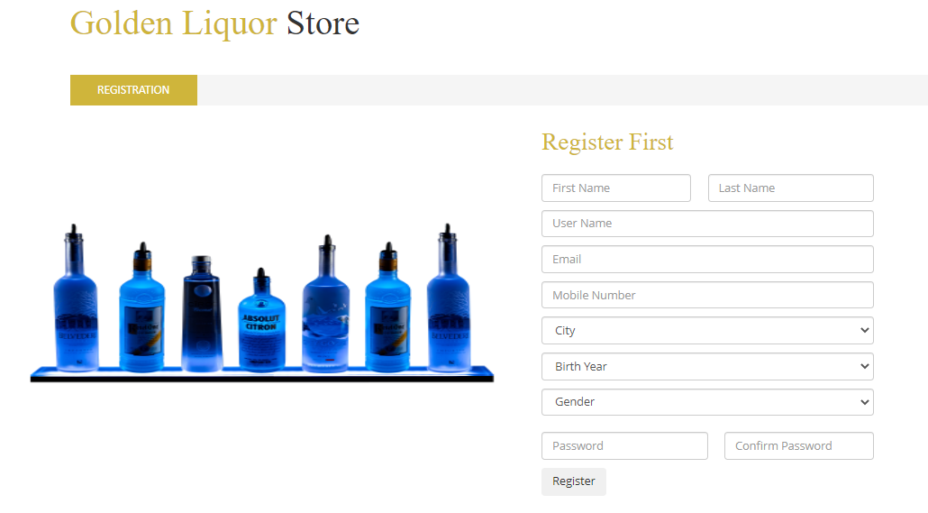

Prepared by: Raveen Jayasooriya

Date: Feb 11, 2023